
0 7 . 1 1 . 2 0 2 3
1

Scheduling - EagleNET

Training Manual for Students

Prepared by
The Degree Completion Team

Introduction

After you have created your Degree Works Plan, you can start your Scheduling the course sections once the schedule is released for the upcoming term(s).

Accessing Plan Ahead in EagleNET
You will need to ﬁrst access your EagleNET portal.

Click here to access Eaglenet



- After logging into EagleNET with your SSO, select Plan Ahead
on the middle left.
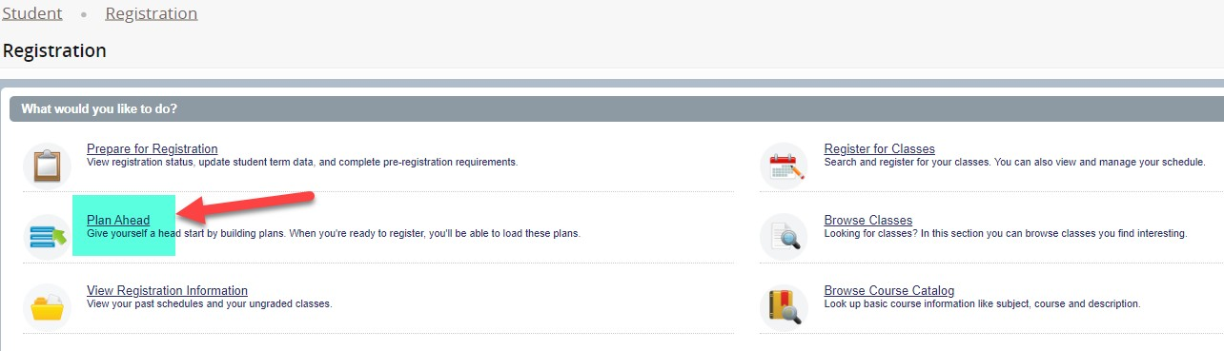

- Choose the term you want to plan sections for (I'm using Fall 2023 as an example). Then click Continue.

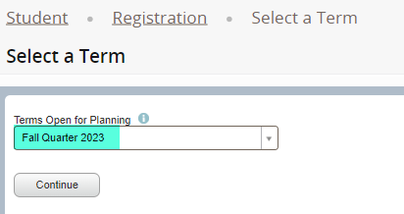

You will notice a few lines here. The top line "Plans you have created for this term: 0" is referring to how many term plans you've created. The bottom line "Number of Degree Works Plans: 1" is referring to how many Long- Term Plans you have Active and Locked in Degree Works Plans.

- To start, you will want to click on Create a New Plan.

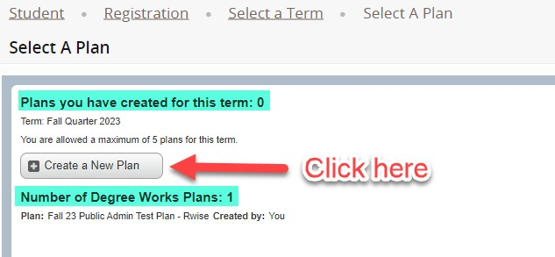

- To see your Long-Term Plan for this term, click on Degree Works Plans.

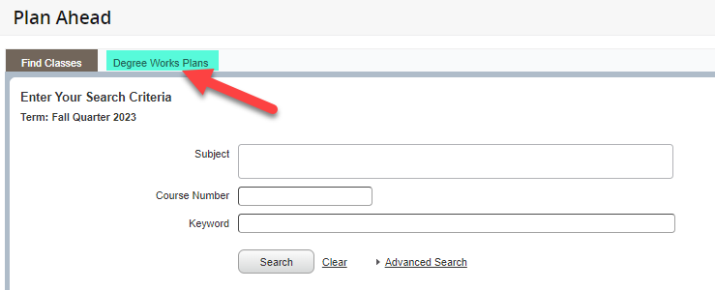

- Then you'll see the courses you've selected for this term. Click on View Sections in order to plan out speciﬁc course sections to start building a schedule.
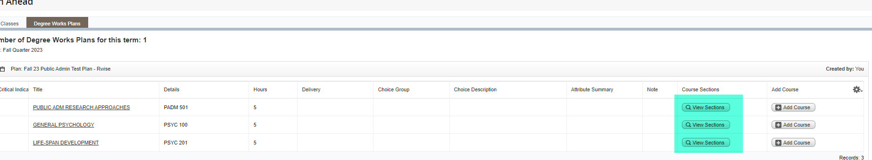

- You'll see every section listed and how many seats are left. Click the Add button to add the section you want.

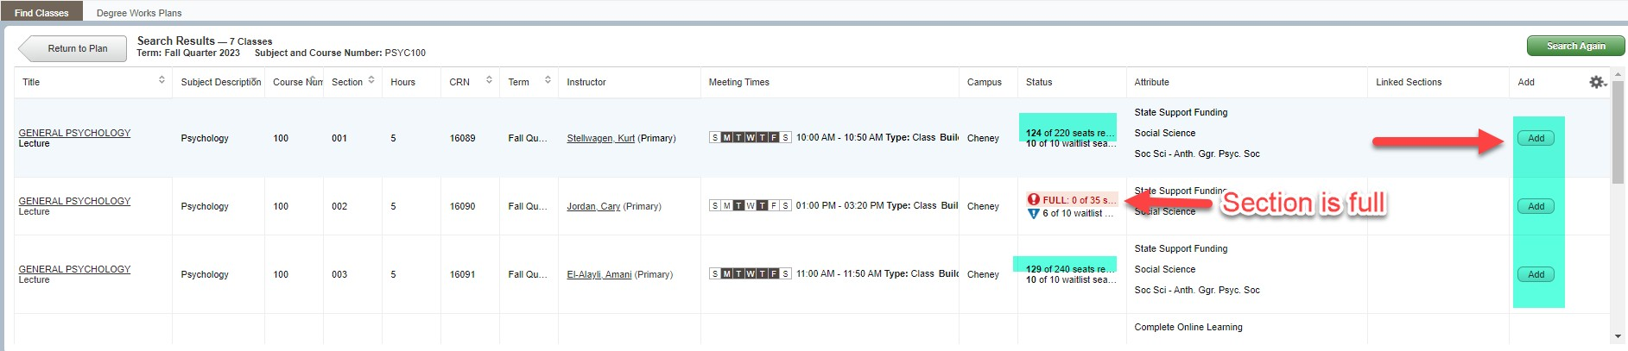

- Then you'll see the bottom left pop up with a calendar view and then the course info on the bottom right. You need to click Return to Plan on the top left to return to your Degree Works Plan.

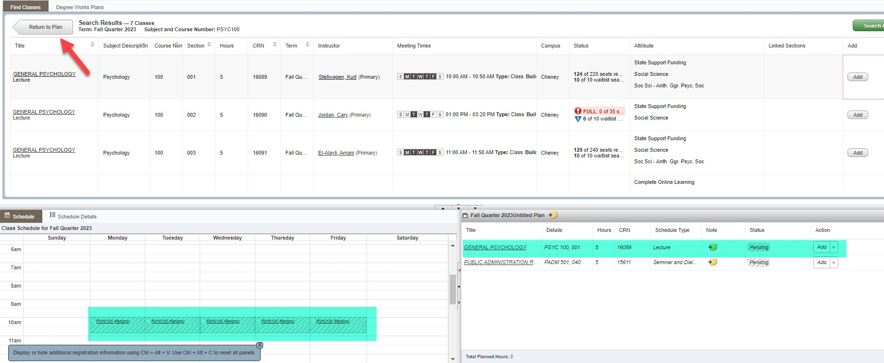

- Continue the process for all of the courses until you have a complete schedule. Then click Save Plan on the bottom right.
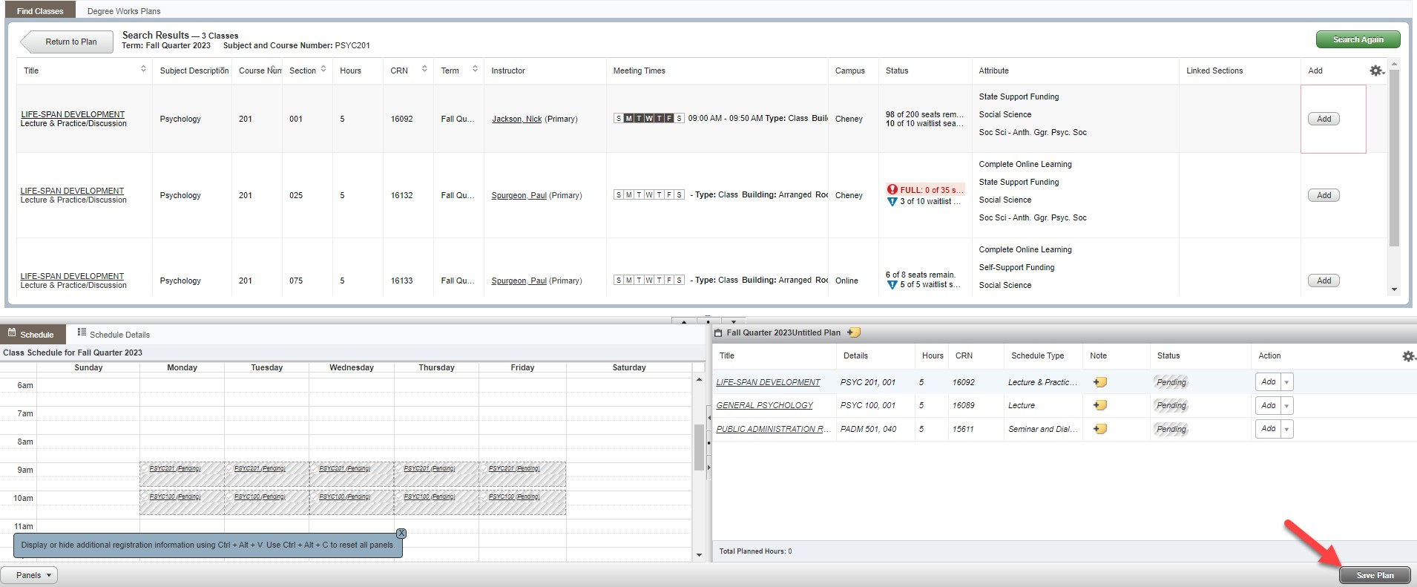

- Give the plan a name and click Save, I'm titling mine "Priority Plan"

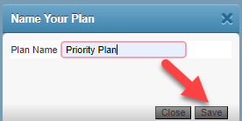

- You will see the status of your classes as Planned. If you want to create a backup plan with different variations of sections, you can! Click on Registration at the top.
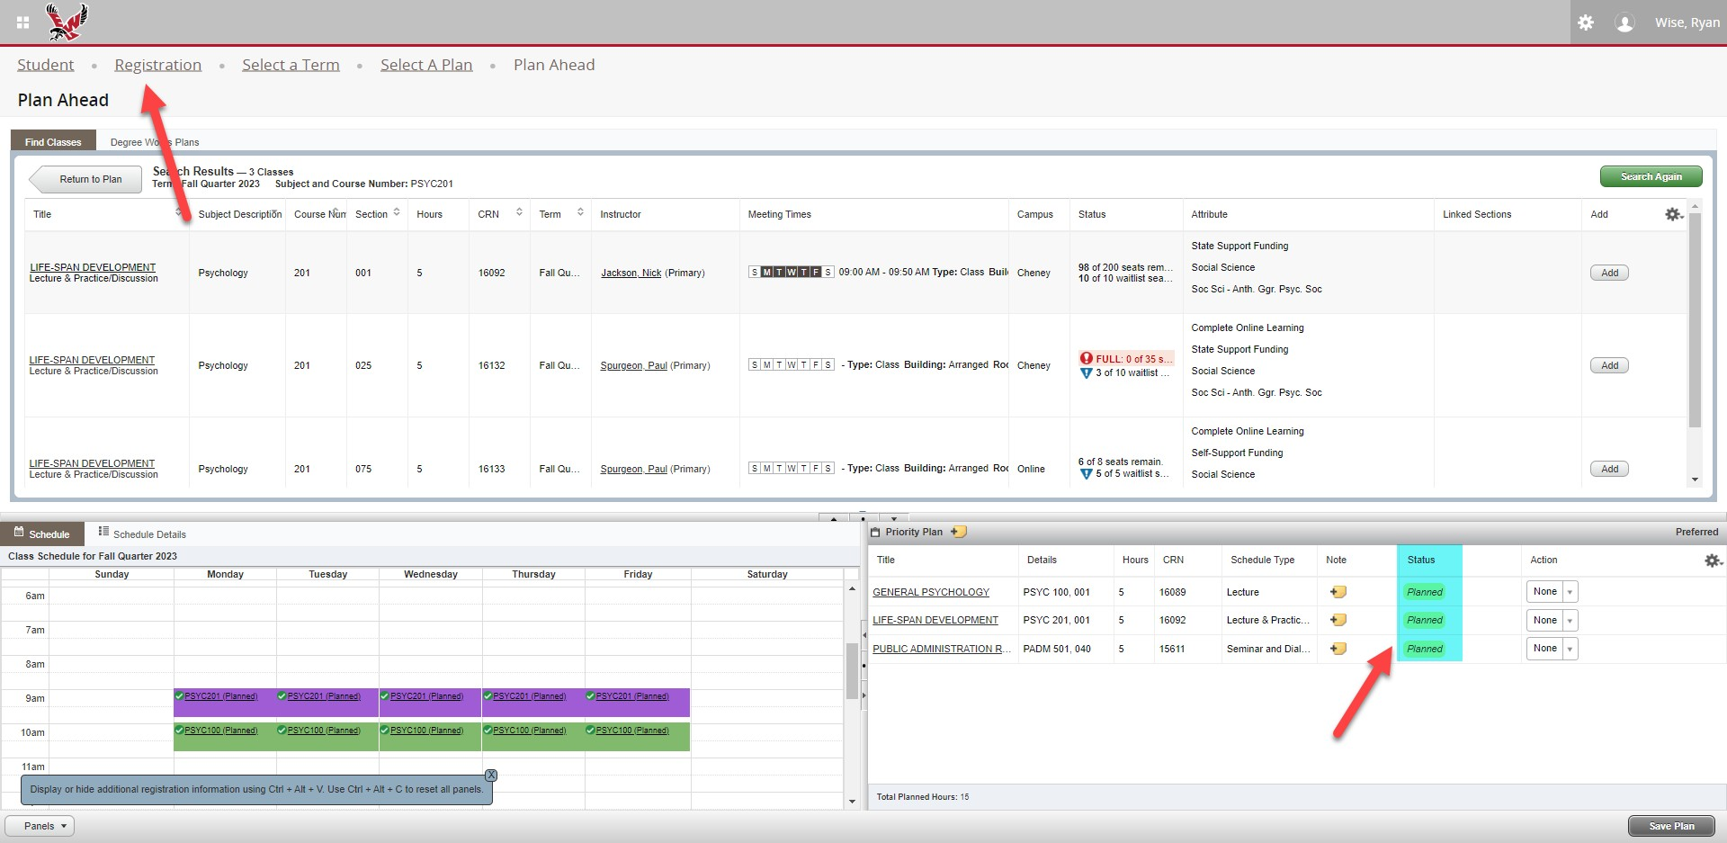

- Then you start with Step 1!

