
0 7 . 1 1 . 2 0 2 3
1

Degree Works Planner - Creating New Plans
Training Manual for Students

Prepared by
The Degree Completion Team

Introduction

The Degree Works Planner is an advising tool that students and advisors can use to map out a clear pathway for timely degree completion. Advising plans created in Degree Works Planner will show students the required courses within their program(s) and a recommended timeline of when they should be completed.

Accessing Degree Works Plans
You will need to ﬁrst access Degree Works

Click here to access Degree Works



- After logging into Degree Works, select Plans at the top of the Degree Works Dashboard and type your ID in the search box and hit enter
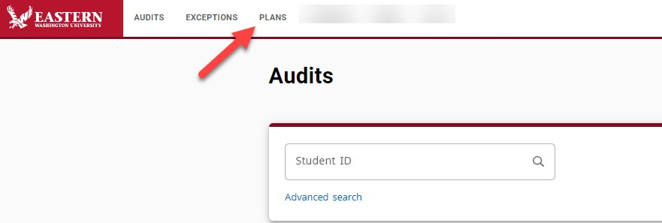
- In the Plan List block, you will see any plans that were previously created
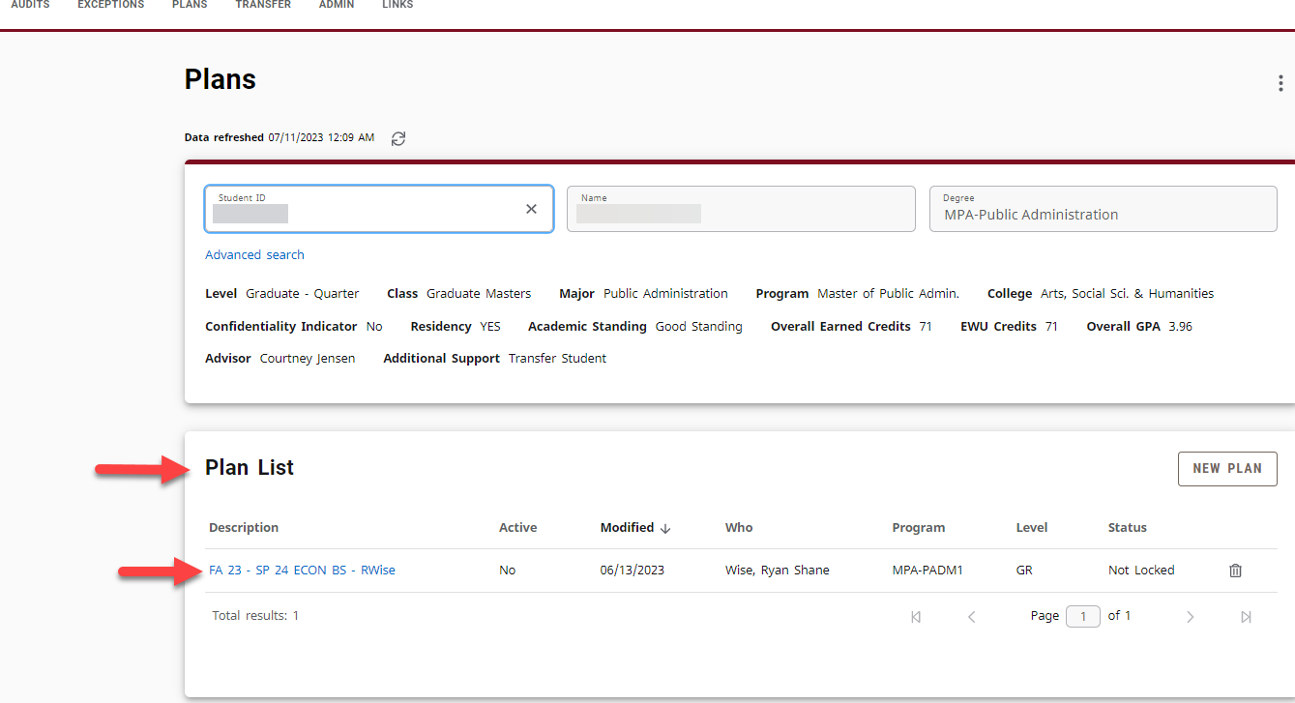

- If you want to create a new plan, and click New Plan, then
Blank Plan.
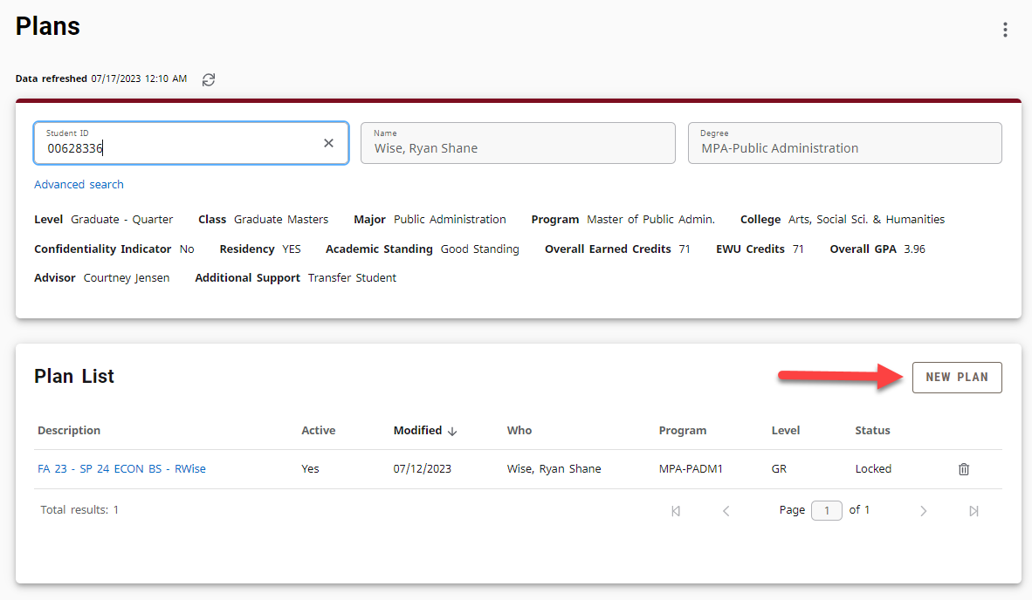
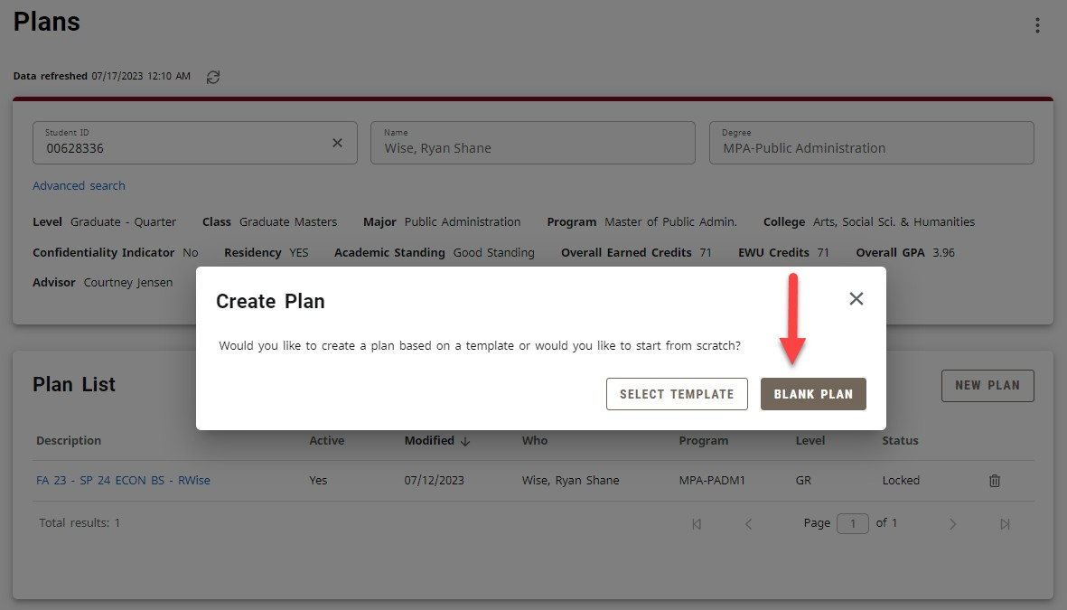

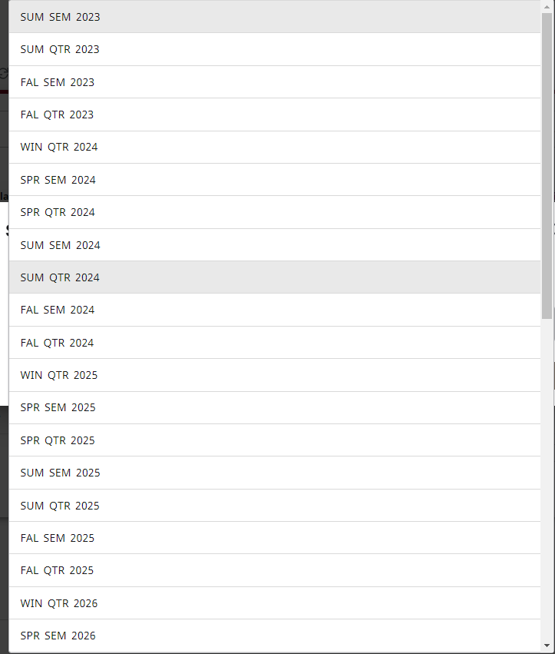
- Select the Start Term from the dropdown list. Please note that there are both Semesters and Quarters on the list, make sure you choose the appropriate term.
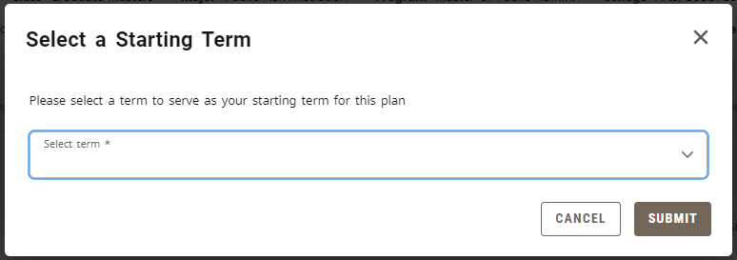

- After you choose the starting term click the Submit button.

- You may get an error message indicating that another plan is "Active". If this is the case, you will need to inactivate the old plan. Please continue to step 8.
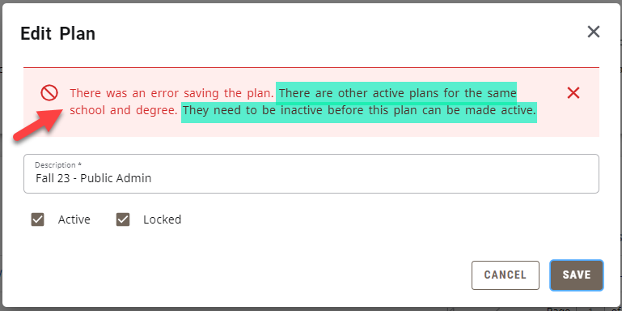

- Check to see which plan is Active from the plan list and then click the Description Title to edit it.
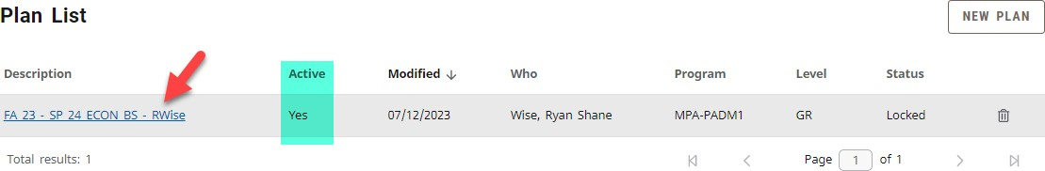
- In the 2nd box, find and click the pencil next to the Plan Title to edit the Active Status.
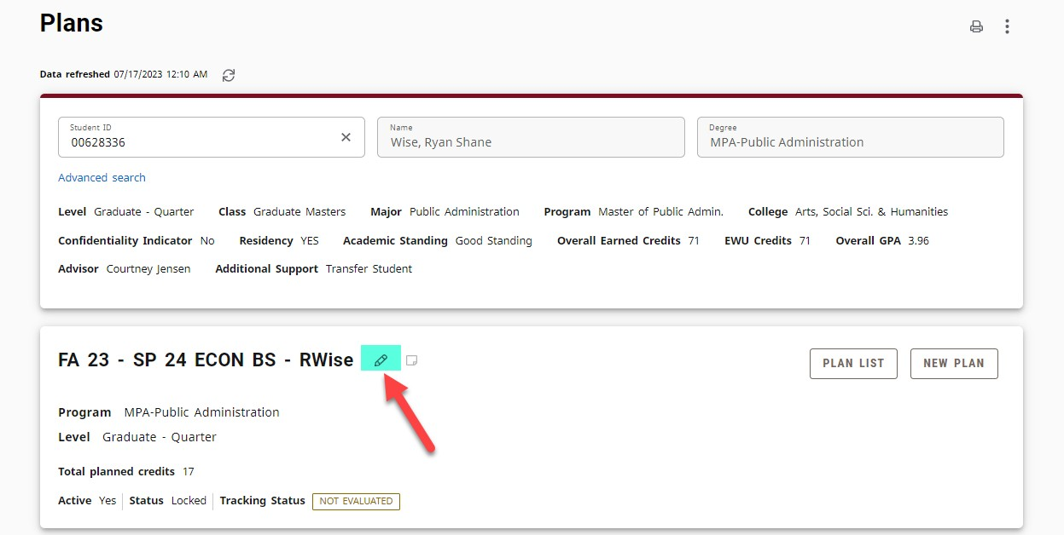

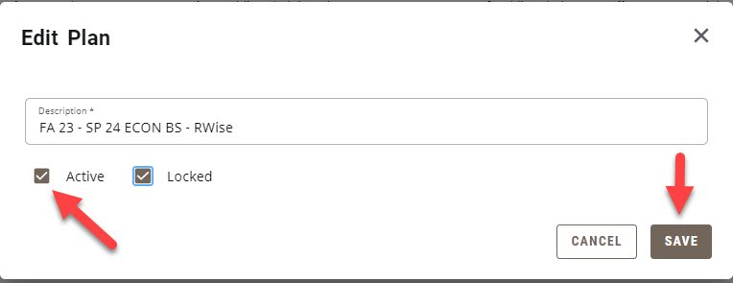
- Then you will want to un-check the Active box so that it is blank and then click Save.

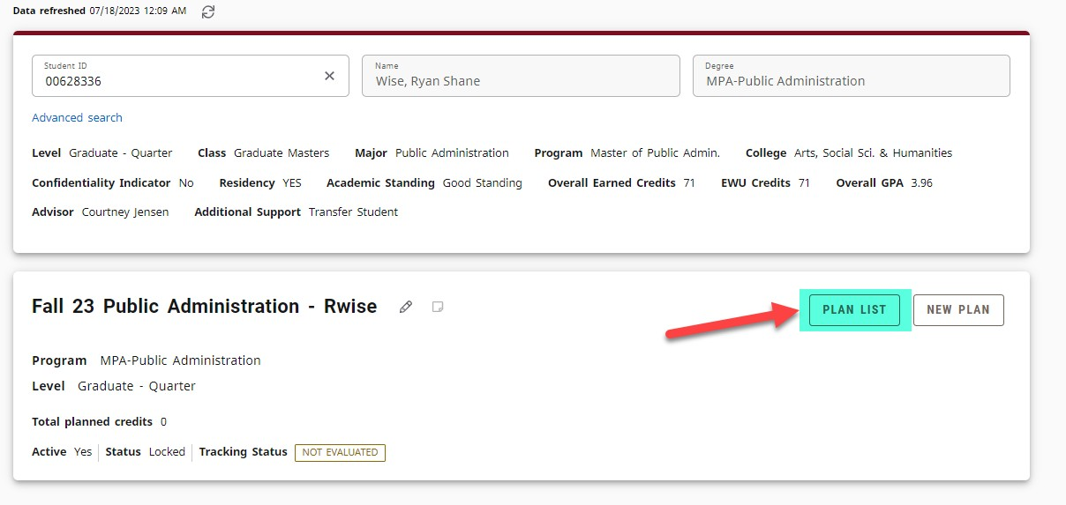
- Then it will bring you back to the Plan. You will want to find the Plan List button on the top right and click it.
- This will bring you back to where you can create a new plan (steps 4-7, but now you won't get the error).

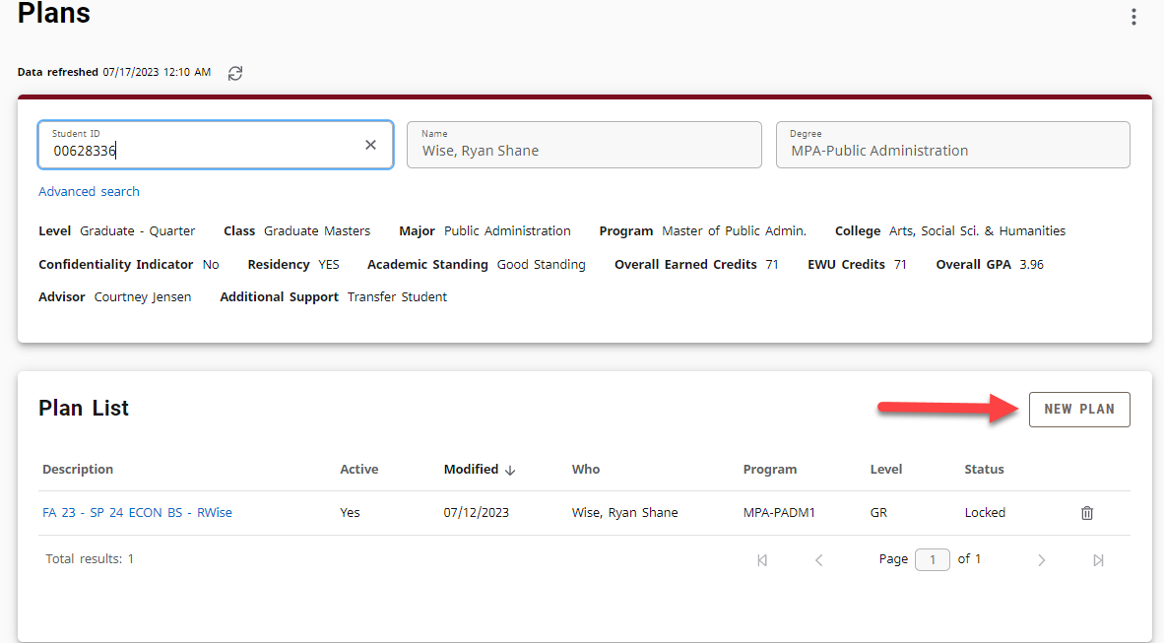

- You will now be able to begin creating your Long-Term Plan. Scroll down until you see the Term, Add Term, and Still Needed areas.

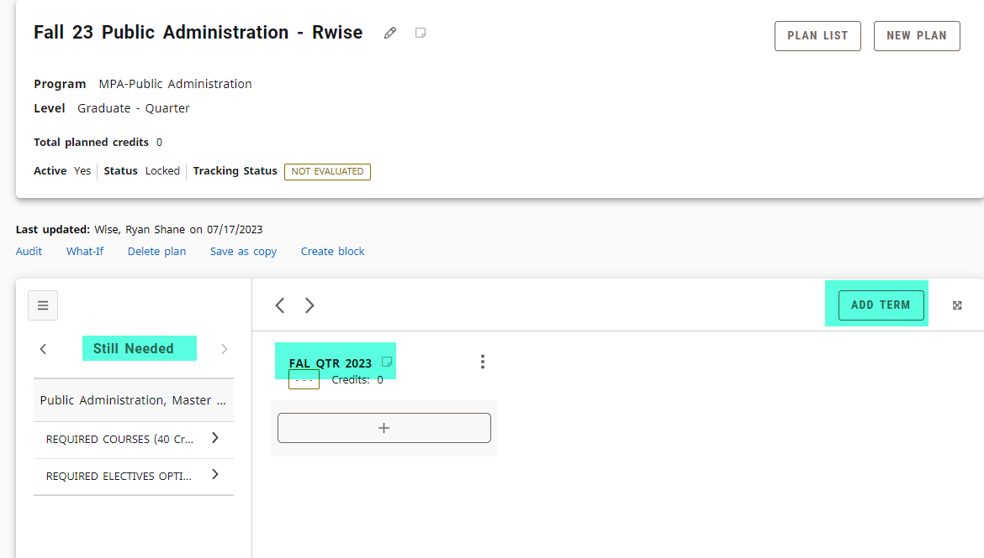

- You can add in as many terms as you need to plan your time here at EWU. The arrows will move you to the hidden terms you've added by clicking the right/left buttons.
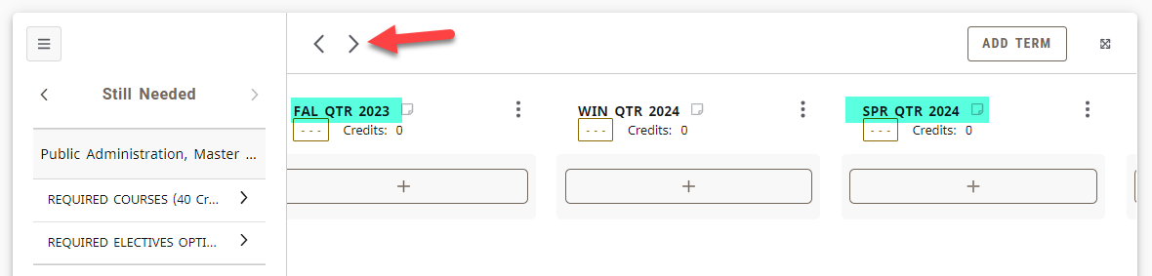
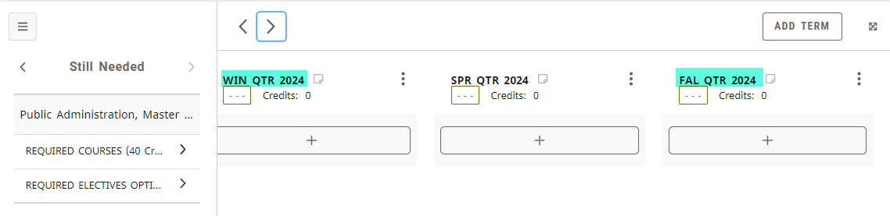

Creating a New Plan
PAGE 9

- On the left, you'll see a list of Still Needed options. This directly relates to your Degree Audit. Click on the arrows to open up the options for that requirement. You can drag and drop the requirements into the terms.
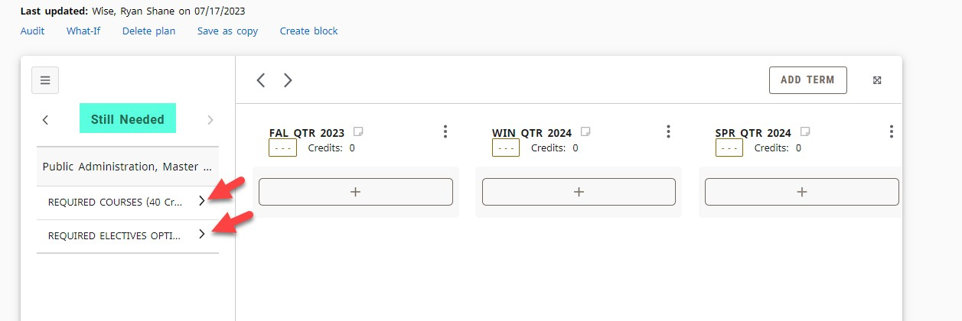
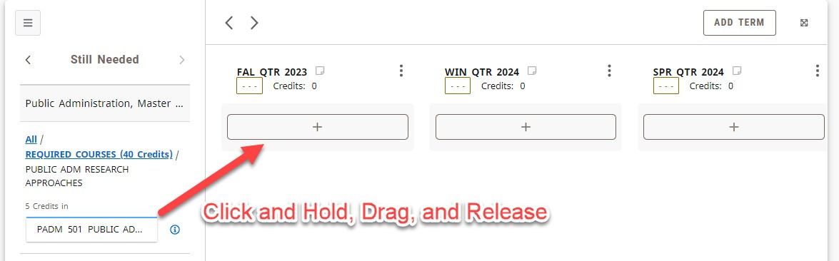

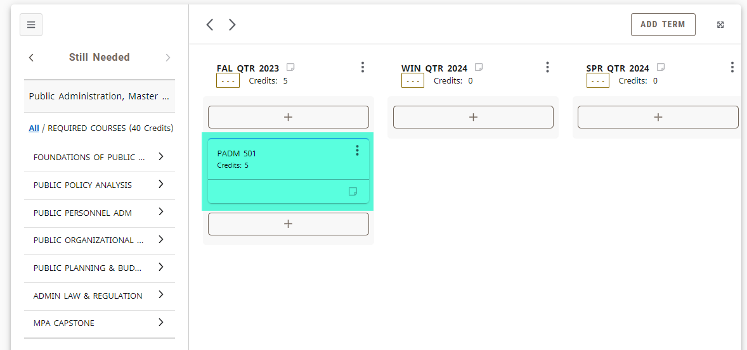

PAGE 10

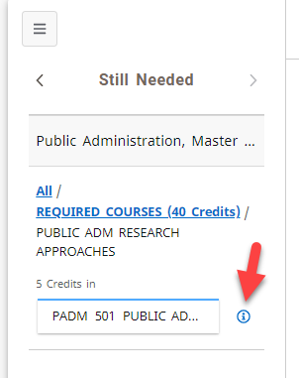
Creating a New Plan

- Now as you are building your schedule, you can check to see if the course is being offered in the next term by clicking the little "i" button next to the course.

- Doing this will open up the Course Information box which will inform you of the details of the course. If the course is being offered, you'll see the term information.
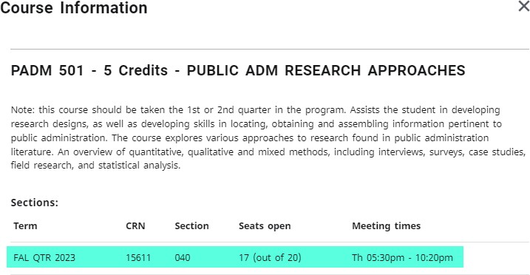

- You'll be able to plan all of the required courses for each term. However, if you need to search for a class that does not show up in the major or general education courses (or if you are undeclared), you will need to do the search function. Click the arrow on the left hand side of Still Needed until you get to Courses.
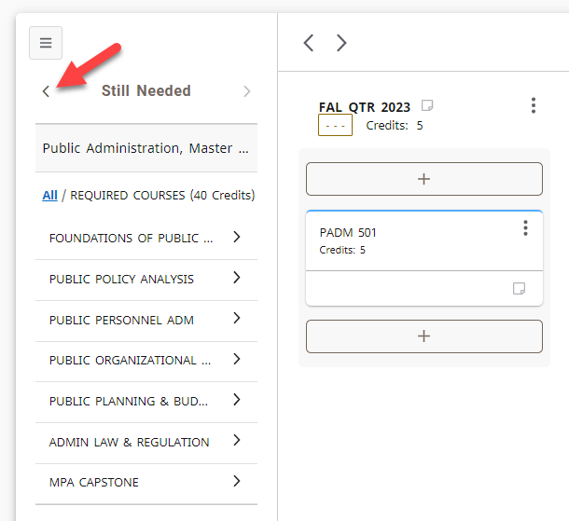
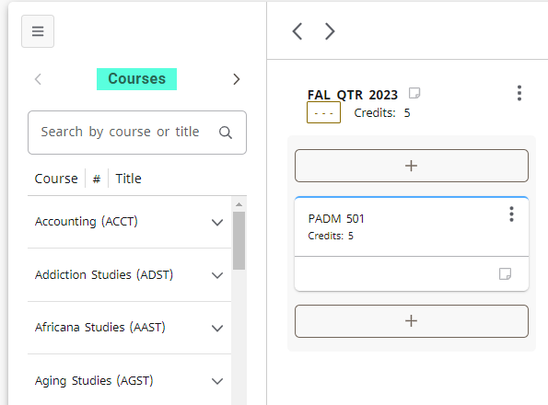
- Then you can type the subject into the search bar (don't use the number as it won't pull up the course). For example, I'll be using History to demonstrate this. I'll be looking for History 389.
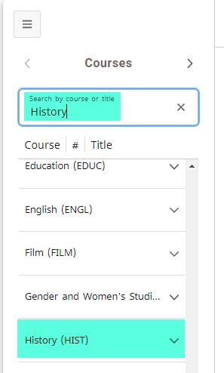

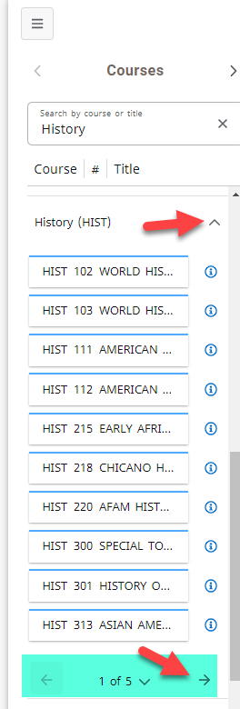
- You'll may need to scroll down to find the subject, but once you find it, click the arrow next to it. This will open up the subject with every available course from the catalog.

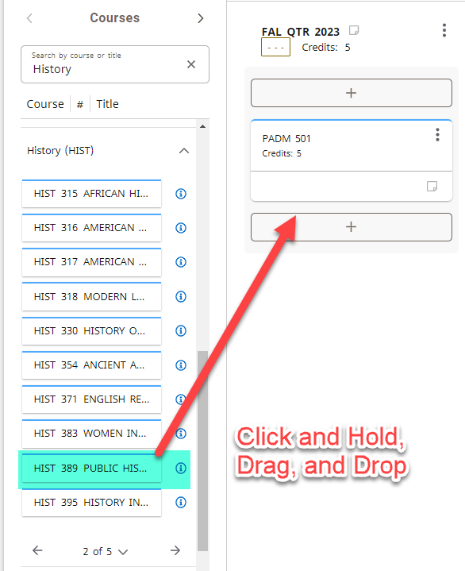
- The courses will go in an acending value. Click the arrow next to the pages to flip to the next set of courses until you find the one you are looking for.

